CITEXPO 2025 Exhibitor Registration Form
Move-in days: Sep. 1st–2nd, Exhibiting days: Sep. 3th–5th
Booth No. :
Venue: Shanghai World Expo Exhibition & Convention Center
Organizer: Reliable International Exhibition Services Co. Ltd.
- Company Information
Corporate name*:
*The Chinese and English Exhibitor Names below will be used in exhibition such as catalogue and booths’ fascia boards etc. Please contact the Organizing Committee before Jun 1st, 2025 should there be any changes.
Contact person: |  |  |  |  |  |  |  |  | Position:
Address: |  |  |  |  |  |  |  |  | Country:
Postal Code: |  |  |  |  | Telephone: |  |  |  |  | Fax:
E-mail: |  |  |  |  |  |  | Website:
Exhibiting Product Types:  (Please circle:) |  |  |  | Tires / Wheel / Maintenance Equipment / Production Material or Equipment / Retreading Material or Equipment / Accessories / Others_________________:
Exhibitor’s Declaration: “We (Exhibitor) have read and agreed to the Agreement stated in the CITEXPO 2025 Exhibitor Rules & Conditions section”
Signature X ____________________________________ Date _________________
2. Space Request :(
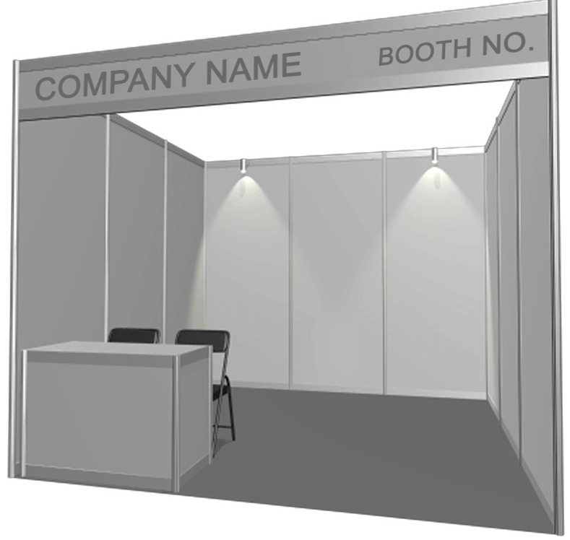
Option 1: Shell Scheme Booth
Standard Booth: US$500.00 / m²
- 9 sqm (3m x 3m) standard booth = USD$4,500.00
Each EVEN 9 m² shell scheme booth includes:
- 3 sided partition walls, carpet, 1 fascia with company name and booth number in standard character, 2 spot lights, 1 socket, power supply (380V / 220V / 5A), 1 counter, 2 chairs, a free exhibitor description entry in the website and the show guide. Any extra uneven square meters will only come with extra partition walls and carpet.
- Basic cleaning of the booth and walkway
We would like to book ____ m² Standard booth = US$ ________

20% additional levy on booth rental shall be levied for requested Corner booth
Option 2: Raw Space (min. 36m²) - US$450.00 / m²
We would like to book _ x _ m (width) = __ m² raw space = US$ _____

Construction management fee and electricity are not included in the rental fee of raw space and these fees will be charged on spot according to the leased area and the usage of electricity.
*Exhibitor will enjoy a free promotion in the Show Guide and the official website (deadlines apply).

3. Advertisement & Promotion
I. Advertising in the Show Directory
The show directory will be printed and distributed to the visiting professionals including relevant associations, manufacturers, suppliers, buyers and those professionals who are unable to attend the fair.
(Tick off the box if necessary)
Page | Size (mm) | Black & White (US$) | 4-Color (US$)
Back Cover | 140 (width) x 210 (Hight) | N/A | - $2,500.00
Inside Front Cover | 140 (width) x 210 (Hight) | N/A | - $2,200.00
Inside Back Cover | 140 (width) x 210 (Hight) | N/A | - $1,900.00
Full Page | 140 (width) x 210 (Hight) | □ $900.00 | □ $1,500.00
1/2 Page | 140 (width) x 104 (Hight) | □ $500.00 | □ $800.00

Advertisement specification:
- Ads Format: jpg or pdf; Resolution: 300dpi; 3mm bleed
- Film production cost: Included in the advertisement fee
- Deadline: The advertiser must provide the ads design by email or parcel post together with the layout before June 26th, 2025
II. Advertisement on Visitors’ Lanyards = US$ 2,400.00
  - Advertiser should provide the artwork by June 26th, 2025 with the following specification: 280mm (max. width) x 8mm (height), one color: jpg format, resolution: 300dpi,
  - The length of each lanyard is about 900mm. The advertisement will be printed on one side evenly spread out the length
□ We would like to book ___ Visitors’ Lanyard Advertisement (s) = US$ __________

III. Hyperlink of Products / Corporate Logo = US$400.00 each
Size: 80 x 40 pixel
Duration: Up to the last day of CITEXPO 2025
Website: http://www.citexpo.com.cn
□ We would like to book ___ logo (s) = US$ __________

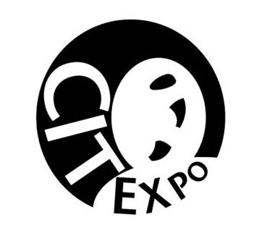CITEXPO 2025 Exhibitor Rules & Conditions
- Definitions:
The Reliable International Exhibition Services Co., Ltd. owns, manages and produces the China International Tire Expo (“CITEXPO”). The Reliable International Exhibition Services Co., Ltd are hereinafter referred to as “Show Management”.
Shanghai World Expo Exhibition & Convention Center is hereinafter referred to as Venue.
The exhibition halls, parking lots, air space and grounds of the Venue are hereinafter referred to as the “Exhibit Area”.
Any person or company to whom Exhibit Area is allotted at his or their request and his or their employees or personnel or agents is hereinafter referred to as “Exhibitor”. The Exhibitor Rules and Conditions are hereinafter referred to as the “Agreement” and constitute the agreement between Show Management and the Exhibitor.
The area allotted to an Exhibitor and stand erected thereon is hereinafter referred to as the “Stand”. Any article, which is referred to in the application for Stand are hereinafter referred to as the “Exhibit”. Any person, firm or Company employed by the Show Management for erection, fitting out or other work on any stand in the CITEXPO is hereinafter referred to as “Contractor”.
- Location and Schedule
The Venue of CITEXPO 2025 is located at No. 850, Bocheng Road, Pudong New Area, Shanghai, China.
The schedule of CITEXPO 2025 is as follow:

Move-in & Set-up: | Monday, Sep. 1st, 2025 | 09:00 – 17:00 (for Raw Space exhibitors only)
Move-in & Set-up: | Tuesday, Sep. 2nd, 2025 | 09:00 – 17:00 (for all exhibitors)
Exhibiting days: | Wednesday, Sep. 3rd, 2025 | 09:30 – 17:00
Exhibiting days: | Thursday, Sep. 4th, 2025 | 09:30 – 17:00
Exhibiting days: | Friday, Sep. 5th, 2025 | 09:30 – 15:00
Dismantling: | Friday, Sep. 5th, 2025 | 15:00 – 17:00

- Application and Payment
  - Approval. Application for rental of Exhibit Area shall be subject to the approval of Show Management, and Show Management reserves the right to reject applications for Exhibit Area with or without cause if in the best interest of the CITEXPO.
  - Payment Schedule. Full Payment should be made in remittance payable to Show Management via telegraphic transfers or bank draft in US funds only upon the receipt of invoice from the Show Management. Show Management will prioritize the Stand location according to the settlement date of the full payment.
- Cancellation and Refunds
Cancellation of all or a portion of any Stand must be made in writing to the Show Management. Refund policy with written notification received:
  - On or before Jun 1st, 2025, or within 14 days of the application date
Show Management shall withhold 25% of the total Exhibit Area rental cost as an administrative fee and liquidated damages for cancellation of all or any part of the confirmed Stand.
  - From June 1st, 2025 to August 31st, 2025
Show Management shall withhold 50% of the total Exhibit Area rental cost as an administrative fee and liquidated damages for cancellation of all or any part of the confirmed Stand.
  - After August 31st, 2025
Show Management shall withhold 100% the total Exhibit Area rental cost as an administrative fee and liquidated damages for cancellation of all or any part of the confirmed Stand.
Reduction of Stand may result in the relocation of your exhibit if it is determined by Show Management to be in the best interest of the CITEXPO. Show Management shall not be liable for interest on any amount refunded.
- Event Cancellation and Postponement
The Show Management has the sole right to make any Decision on canceling or postponing CITEXPO for any reasons. Refunds, credits or other reasonable arrangement will be provided to all paid accounts according to the arrangement set by the Show Management.
- Eligibility
Show Management reserves the right to determine eligibility of Exhibitor for inclusion in the CITEXPO prior to, or after, execution of the Agreement.
  - Criteria.
To exhibit in the CITEXPO, Exhibitor must meet one of these criteria:
Product displayed must be manufactured, packaged and marketed under Exhibitor’s trade style or brand name.
Product displayed is not manufactured by Exhibitor, but Exhibitor has sole and exclusive right to sell the product.
  - Products Displayed.
No Exhibitor shall display any product or display or distribute advertisements for a product, which infringes upon the registered trademark, copyright or patent of another company, as has been determined by a court of competent jurisdiction.
Show Management, in its sole judgment, will determine the appropriateness of products exhibited, and reserves the right to prohibit display or advertisement of products, which are in violation of the Agreement.
- Assignment
  - Floor Plan.
Should situations or conditions warrant, Show Management reserves the right to rearrange Exhibitor or adjust the floor plan to accommodate the best interest of the CITEXPO. Changes of the floor plan may occur at any time to accommodate needs of CITEXPO.
  - Stand.
The method of determining Stand assignment shall be established by Show Management and may be changed from time to time without notice to Exhibitor in order to accommodate what Show Management perceives as the best interest of the CITEXPO. No rights or privileges are created for any Exhibitor as a result of previous Stand assignments or years of participation in the CITEXPO.
  - Subletting Stand.
Exhibitor shall not assign, sublet, share or apportion the whole or any part of Stand, or have representatives, products, equipment, signs or printed materials from other than its own firm in the contracted Stand without the written consent of the Show Management.
- Admission
  - Badges.
Exhibitor badges will be issued in the name provided on the Exhibitor application form only. Admission to the CITEXPO is by official reiterated badge. Badges of Exhibitors are the property of Show Management and are not be ordered for or transferred to buyers or non-employees. Exhibitor waives any right to claim for damages against CITEXPO for the ejection of any objectionable person or any persons who have or likely will create a danger to public health and/or safety.
  - Children.
Infants and children under 16 years of age will not be allowed anywhere in the Exhibit Area, at any time.
  - Pre-exhibiting Hours Entry.
Exhibitors are allowed to enter the exhibition hall half hour prior to the opening of each exhibiting day of CITEXPO.
- Set-up
  - Display Installation.
All displays and exhibits must be in place of Exhibit Area. All displays, exhibits, cartons and refuse must be removed from the aisle.
  - Late Installation.
If installation of any crated exhibit has not started by 9:30 to 17:00 on Sep. 1^{std} – 2nd, 2025, in the sole and absolute discretion of the Show Management and no alternative arrangements for set-up have been made by the Exhibitor in advance and approved by Show Management, then Show Management shall erect the exhibit and Exhibitor will be billed for and agrees to pay for all charges incurred. Show Management shall not be liable for damages that may occur during this exhibit set-up.
  - Stand Abandonment.
Any Stand not claimed and occupied by 9:30 , Sep 3rd, 2025, may be resold or reassigned by Show Management without obligation on the part of Show Management for any refund whatsoever.
  - Display Vehicles.
Display vehicles must have battery cables disconnected, fuel tanks not more than 1/4 full (maximum five liters), filler caps locked and/or sealed with tape and alarm systems deactivated during exhibiting hours. Display vehicles will be permitted to occupy no more than 80% of the contracted Stand.
- Dismantling
  - Timely Dismantle.
Exhibitor agrees to dismantle the Exhibit as soon as practical after the end of the CITEXPO. All freight must be removed from the hall no later than 17:00, Sep 5th, 2025 or the Contractor will remove it at the Exhibitor’s expense. Exhibitor further agrees to indemnify and save Show Management harmless against any and all claims which may arise by virtue of damage to the premises caused by Exhibitor’s display or costs paid by Show Management due to holding over by Exhibitor past its allotted time of occupancy.
  - Early Tear down.
Exhibitor shall not initiate tear down or abandon exhibit prior to the official dismantling time on , Sep 5th, 2025. Violation of this paragraph will cause Exhibitor to be fined US$ 500.
  - Dismantling Security.
Exhibitor personnel should remain in their Stand until all freight of Exhibitor are secured and accepted by the freight carrier. Show Management and the Contractor assume no responsibility for Exhibit left unattended in the Exhibit Area during dismantling. Exhibitor shall not allow Exhibit or materials to remain in the Exhibit Area after 17:00 , Sep 5th, 2025. If Exhibit or materials remain after such time, Show Management or Constructor may remove it, and Exhibitor shall be liable for and agrees to pay all costs for dismantling and storage. Show Management shall not be liable for any damage to the Exhibit or materials due to removal or storage.
- Operation and Conduct
  - Regulation & Restriction. Show Management reserves the right to regulate and/or restrict Exhibit to a reasonable noise level and to suitable methods of operation and display. Show Management deems that 80 Decibels is a reasonable noise level. Harmful or noxious odors or fumes must be negligible and contained within Exhibit. Neither the Stand nor Exhibit Area shall be used for any improper, immoral, illegal or objectionable purpose. If for any reason Show Management deems an Exhibit and/or its contents objectionable, the Exhibit shall be subject to removal at Exhibitor’s sole expense. This reservation includes persons, things, conduct, printed matter, signs, or any item of poor character, which in the sole judgment of Show Management is detrimental to the CITEXPO. In the event such a restriction is enforced, Show Management shall not be liable for refund of Stand rental fees or equipment rental fees, except at its’ sole discretion. Exhibitor hereby expressly waives any right and all claims, actions or demands for damages, costs and expenses, including legal fees, against the Venue, Show Management, their directors, officers, agents, employees and / or servants for such restriction or removal.
  - Prohibited Displays. No animals, reptiles, birds, rodents, fish or insects may be used as part of any Exhibit. Only helium balloons with a diameter larger than 36” are permitted within the Exhibit Area and must adhere to height limitations for the Stand. Absolutely no helium balloons shall be permitted for giveaway or sale. Cold air balloons are permitted with written permission of Show Management.
  - Exhibit Obstructions. Exhibitor is not allowed to obstruct the view, occasion injury or adversely affect the displays of other Exhibitors.
  - Exhibit Personnel. Attendants, models, and other employees must confine their activities to the contracted Stand. Exhibitor personnel and representatives may not enter the Stand of another Exhibitor without permission from that Exhibitor. Violators will be ejected from the CITEXPO. Exhibit personnel should wear appropriate apparel at all time.
  - Damages. Exhibitor shall yield the Exhibit Area back to the VENUE at the conclusion of the CITEXPO in good condition and repair, ordinary wear and tear excepted. Any costs incurred by the Show Management & VENUE to restore the Exhibit Area to its condition prior to the CITEXPO, including but not limited to removal of signs, balloons, tape and other items not removed by Exhibitor shall be the responsibility of Exhibitor. Exhibitor is responsible for all damage to any property caused by the Exhibitor personnel.
  - Advertising. Exhibitor shall not, without the written consent of Show Management, distribute, or permit to be distributed, any advertising matter, literature, stickers, souvenir items or promotional materials in or about the Exhibit Area except from its own Stand.
Exhibitor shall not post or exhibit any signs, advertisements, show bills, lithograph poster, stickers or cards of any description on any part of the premises of the Venue, except within the Exhibitor’s Stand and upon such Stand as is made available for such purposes by the Venue.
  - Food and Beverages. Food and/ or beverage items served within an Exhibitor’s Stand must be provided by the official caterer of VENUE. Preparation of food within the contracted Stand is prohibited.
In no event will Exhibitor bring into the Venue, or any of it facilities, any food, whether prepared or unprepared, or beverages of any kind whatsoever, without the prior written permission from the official caterer of VENUE.
  - Photography / Video / Recording. No exhibit, performance or event presented at the CITEXPO shall be photographed, videotaped, broadcast or recorded for commercial use, sale or distribution of any kind without the express written consent of Show Management.
Exhibitor shall not photograph or videotapes the Exhibit or product of another Exhibitor. If found in violation of this section, Exhibitor agrees to surrender film or tape immediately at the request of Show Management.
- Compliance with Laws
  - Laws and Ordinances. Exhibitor agrees to comply with and be bound by all laws of the China, all ordinances of the municipality of Shanghai and wherever applicable, all rules and regulations of the Police Department and Fire Department and those policies and criteria, which have been established by the Venue for use of the Exhibit Area.
  - Fire Regulations / Fire Proofing / Codes. Exhibitor must conform to all standard fire codes of the municipality of Shanghai. Combustible materials or explosives are not permitted in or around the Exhibit Area without written permission from Show Management. Exhibitor shall not allow its display to block the view of, or impede access to fire alarm boxes, fire hose cabinets, fire extinguishers, or other safety equipment. Smoking is prohibited in the Venue whenever.
  - Inspection. All displays will be inspected during set-up days and any Exhibitor deviating from the regulations must make modifications to its Exhibit at Exhibitor’s expense prior to CITEXPO opening.
- Waiver of Liability and Subrogation
Show Management shall not be responsible for any damage or injury that may happen to the Exhibitor or its agents, servants, employees or property from any cause whatever except the gross negligence or willful misconduct of Show Management, its servants or employees, arising out of Show Management duties and responsibilities under the Agreement. Exhibitor expressly releases Show Management, its directors, officers, agents, employees, and/or servants from any such loss, damage or injury.
CITEXPO and the official vendors of CITEXPO do not provide any form of insurance to cover Exhibitor activities at the CITEXPO and assume no liability or responsibility for loss or damage by Exhibitor due to fire, theft, breakage or any other reason.
Show Management and the Exhibitor agree to waive the right of subrogation by their insurance carriers to recover loss sustained under the respective insurance contracts for real and personal property.
Show Management, its staff, employees, or agents assume no responsibility or liability whatsoever in matters relating to restrictions imposed on any Exhibitor by any government agency.
Exhibitor shall obtain workers compensation insurance, and provide proof of same to Show Management if requested by Show Management, for all employees of Exhibitor.
- Indemnity
The Exhibitor is responsible for any and all demands on account of any injury or death, or damage to property occurring in or upon any portion of the Venue leased or used by Exhibitor which are caused by the acts or omissions of Exhibitor, or its employees, representatives, servants, agents, licensees, invitees, patrons, guests, or Contractor. Exhibitor shall defend, indemnify and hold harmless Show Management; it’s officers, employees, and agents from and against any and all claims, demands, actions, causes of actions, penalties, judgments, and liabilities of every kind and description (including court costs and reasonable attorney’s fees) for injury to and death of persons, and damage to and loss of property which are caused by, arise from or grow out of Exhibitor’s use of occupancy of the premises or from any breach by Exhibitor of any condition of this Contractor, or from any act or omission of Exhibitor, or its’ employees, representatives, servants, agents, invitees, patrons, guests, licensees, or Contractor.
- Violation
The Exhibitor shall be bound by the Agreement set forth herein, and by such additional Agreement, which may be established by the Venue and the Show Management. Show Management shall have the power to adopt and enforce all the Agreement, and their Decision on these matters will be final. All matters and questions not covered by the regulations shall be subject to the final judgment and Decision of Show Management.
Any violation by the Exhibitor of any of the terms and conditions herein shall subject Exhibitor to cancellation of the Agreement to occupy Stand and to forfeiture of any monies paid on account thereof. Upon due notice of such cancellation, Show Management shall have the right to take possession of the Exhibitor’s Stand, remove all persons and properties of the Exhibitor and hold the Exhibitor accountable for all risks and expenses incurred in such removal.

CITEXPO Show Management c/o Reliable International Exhibition Services Co. Ltd.
Add: Rm 1702, Bldg 6, SOHO New Town, 88 Jianguo Road, Chaoyang District, Beijing, P.R. China 100022
Tel: +86 10-8589-8181 (General) Fax: +86 10-8589-8180
E-mail: citexpo@reliable.org.cn
Contact persons: Mr. Cyrus Cheung
End

